Michael Sherman and Joe Monaghan

If the video does not work on the Git Hub repository, then you can watch the catapult in action on Michael Sherman’s Google Site.

Michaud

Electronics

27 February 2015

Final Project Description

We had the idea to build a catapult. A vex motor will be wired to the Arduino bread board to wind up a rubber band. The rubber band will be attached to a plastic spoon that will bend on the axel of a bipod with a rod running through the middle. The rubber band will wind back, the spoon will bend over, and there will be potential energy stored in the spoon. There will also be a rubber band attached to the front of the spoon so as to create more tension for the projectile to launch farther. Next, we will program a photo resistor to cause the vex motor to spin the wheel the opposite direction (back towards the catapult) so that the projectile will launch when the photo resistor detects darkness. We plan to use LED’s and sounds from the piezo to indicate what step of the launch sequence the catapult is in at any given moment

Top View

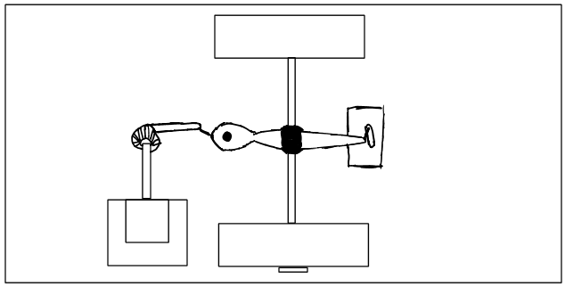

Front View

